**SYLLABUS OF CLASS 10 - 2024**

**MATHEMATICS**

**1ST SUMMATIVE EXAMINATION: -**

1. QUADRATIC EQUATION IN ONE VARIABLE

2. SIMPLE INTEREST

3. THEOREM RELATED TO CIRCLE

4. CUBOID

5. RATIO AND PROPORTION

6. COMPOUND INTEREST / UNIFORM RATER OF INCREASE OR DECREASE

7.THEOREM RELATED TO ANGLE ON A CIRCLE.

8. RIGHT CIRCULAR CYLINDER

9. QUADRATIC SURDS

10. THEOREM RELATED TO CYCLIC QUADRILATERAL.

**2ND SUMMATIVE EXAMINATION**

11. CONSTRUCTION OF CIRCUMCIRCLE AND INCIRCLE OF A TRAINGLE

12. SPHERE

13. VARIATION AND QUADRATIC EQUATION

14. PARTNERSHIP BUISNESS

15 THEOREMS RELATED TO TANGENT TO A CIRCLE

16. RIGHT CIRCULAR CONE

18. THEOREMS RELATED TO SIMILARITY

**3RD SUMMATIVE EXAMINATION**

17 CONSTRUCTION OF TANGENT TO A CIRCLE

20. TRIGNOMETRY TO A CIRCLE

21. CONSTRUCTION : DETERMINATION OF MEAN PROPORTIONAL

22. PYTHAGORAS THEOREM

23.TRIGNOMETRY RATIO AND TRIGNOMETRIC IDENTITES

24. TRIGNOMETRIC RATIO OF COMPLEMENTARY ANGLES

25. APPLICATION OF TRIGNOMETRIC ANGLES : HEIGHT AND DISTANCE

26. STATISTICS: MEAN, MEDIAN , OGIVE , MODE

**SUBJECT ENGLISH II**

**1ST SUMMATIVE**

1. FATHER’S HELP

2. FABLE

3. THE PASSING AWAY OF BAPU

**2ND SUMMATIVE**

4. MY OWN TRUE FAMILY

5. OUR RUNAWAY KITE

6. SEA FEVER

**3RD SUMMATIVE**

7. THE CAT

8. THE SNAIL

REVISION WORK

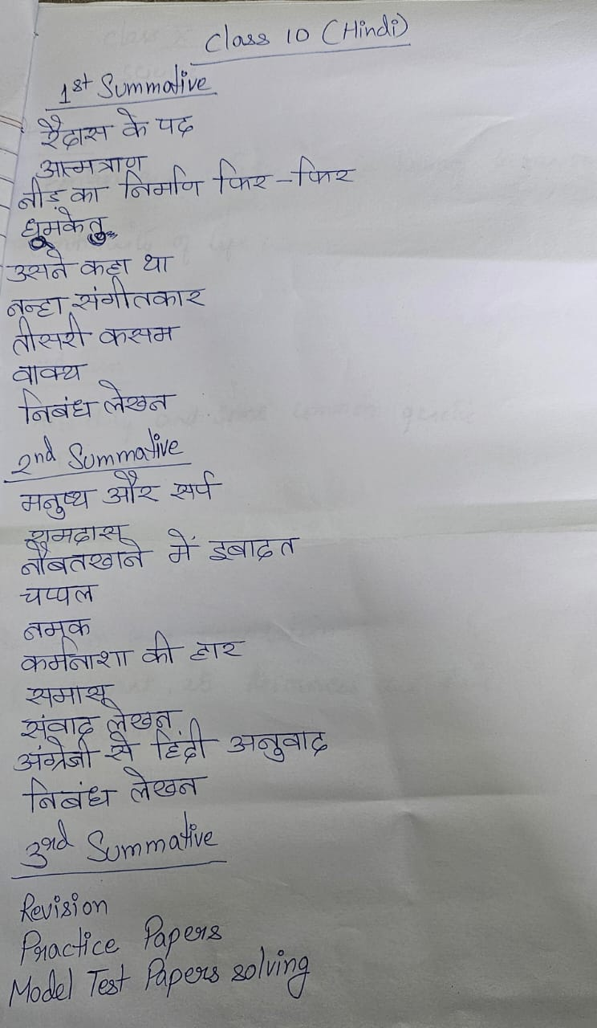

**L.SCIENCE**

**1ST SUMMATIVE**

1. CONTROL AND COORDINATION IN LIVING ORGANISM

2. CONTINUITY OF LIFE

**2ND SUMMATIVE**

1. HEREDITY AND SOME COMMON GENTIC DISEASES

**3RD TERM**

1. EVOLUTION AND ADAPTATION

2. ENVIRONMENT, ITS RESOURCES AND THEIR CONSERVATION.

**GEOGRAPHY**

**1st SUMMATIVE**

1. EXOGENETIC PROCESSES AND RESULTANT LANDFORMS.

3. HYDROSPHERE

5. INDIA (PG 67 - 90 )

**2ND SUMMATIVE**

2. ATMOSPHERE

4. WASTE MANAGEMENT

5 INDIA

**3RD SUMMATIVE**

5. INDIA PG (116- 143)

6. SATELLITE IMAGERY AND TOPOGRAPHICAL MAP

**P.SCIENCE**

**1ST SUMMATIVE EXAMINATION**

1. CONCERNS ABOUT OUR ENVIRONMENT

2. BEHAVIOUR OF GASES

3. THERMAL PHENOMENA

8. PHYSICAL AND CHEMICAL PROPERTIES

**2ND SUMMATIVE EXAMINATION**

3. CHEMICAL CALCULATIONS

5 LIGHT

7 ATOMIC NUCLEUS

6. ELECTRICITY

**3RD SUMMATIVE EXAMINATION**

PREVIOUS YEAR QUESTION PAPERS

SAMPLE QUESTION PAPERS

**ENGLISH**

1. SENTENCE

2. PHRASE AND CLAUSE

3. NOUN

5. PRONOUN

8. ADJECTIVE

9. VERB

14. ADVERB

16. CONJUCTION

15. PREPOSITION

6. ARTICLES

17. PHRASAL VERB

10. TENSE

WRITING –

PARAGRAPH

NOTICE

LETTER.

COMPREHENSION

**2ND SUMMATIVE**

11. VOICE

18 SPEECH

20. JOINIGN AND SPLITTING OF SENTENCE

19. TRANSFORMATION OF SENTENCE

COMPREHENSION

WRITING – STORY, DIALOGUE AND REPORT

**3RD SUMMATIVE**

REVISION

SET SOLVE

**HISTORY**

**1ST SUMMATIVE**

1. IDEAS OF HISTORY

2. REFORM : CHARACTERISTICS AND OBSERVATIONS

3. RESISTANCE AND ANALYSES

4. EARLY STAGES OF COLLECTIVE ACTION : CHARACTERISTICS AND ANALYSES

**2ND SUMMATIVE**

5. ALTERNATIVE IDEAS AND INITIATIVES

6. PEASANT WORKING CLASS AND LEFTIST MOVEMENTS IN 20TH CENTURY INDIA

7. MOVEMENTS ORGANISED BY WOMEN, STUDENTS AND MARGINAL PEOPLE IN 20TH CENTURY INDIA

8. POST – COLONIAL INDIA : SECOND HALF OF THE 20TH CENTURY (1947-1964)

**3RD SUMMATIVE – REVISION**

PREVIOUS YEAR QUESTION SOLVE

SET SOLVE